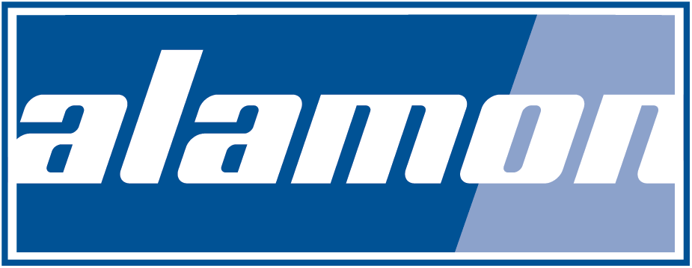

BESS Modular Container Installation Services
High Level Scope of Work

- Project Management

- Site Supervision

- CIVIL Construction
  - Site construction manager
  - Site Preparation/Clearing and Grubbing
  - Backfill, Compaction and Inspection
  - Erosion Contraol/De-Watering
  - Final Grading
  - Pad foundations & concrete work
  - Escavation, Trenching and Grading
  - Laying Conduit
  - Ground grid and cadwelding
  - Fencing

- Modular Container off loading and placement
  - Modular Container damage inspection
  - Crane & rigging services
  - External ground connections

- Equipment and cabling damage inspections
  - Pre power-up NEC quality inspections and defect corrections
  - Visually inspect BESS Equipment and batteries for damage
  - Check cable tray and ironwork for loose hardware
  - Check communications & low voltage cabling for loose connections
  - Internal Ground Ring retorque
  - Ground fault ohms testing between each connection
  - Battery strapping retorque
  - Battery serial number and voltage readings log
  - Inspect piping and bracing

- Externally mount HVAC units and exterior lighting
  - Caulking around HVAC units and vents
  - AC cabling connections to commercial power
  - Power up and operational verification
  - Capacity and controller function testing
  - Refrigerant & condensate line inspection
  - Water intrusion testing
  - Exterior light installation and testing
  - Drip rail inspections

- Communications cabling to Demarcations
  - Ethernet cabling, connecting, and data test verification
  - Fiber cabling, splicing, and OTDR test verification

- Fire suppression inspections and alarm system verification
  - Fire tanks
  - Sensor testing
  - Alarm testing
  - Cylinder Pressure verification
  - Agent in cylinder
  - Smoke detectors
  - Abort stations
  - Audible signals
  - Manual pull stations
  - Visual signals
  - Release solenoid
  - Door and fan test

- A/C connections from the modular container to the transformers

- Battery Load testing

- Final quality inspections

Energy Services options if Batteries and Electronics are shipped separately from the Modular Container
*Additional services including the items that apply above

- Equipment offloading and inventory

- Switchboard installation

- Battery Rack Installation

- Battery Module Installation

- Low & Medium voltage AC cabling

- Cable Megger test verification

- Ground fault ohms testing between each connection

- Electronic equipment Installation
  - Battery Maintenance System, Node controllers, Inverters, Uninterrupted Power Source

- Communications Rack installations
  - Fiber and Ethernet Patch panels
  - Communications cabling and data test
  - Fiber Ring cabling, splicing and OTDR testing
  - Temperature sensor and leak rope installation and test
  - Emergency Stop cabling and test
  - Camera system installation turn up and test
  - Wireless Access Point installation and test
  - Alarm system cabling

- Fire suppression system installation

- Battery and Equipment Maintenance Services

- Final quality inspections

Alamon provides turnkey solutions, including Civil Construction and Electrical low/medium voltage interconnections, with our BESS installation services by working with trusted partners in most geographic locations.
For inquiries and a complete list of equipment or services offered, please contact

Troy Reeves at troy@alamon.com or call at 406-253-5768
David Dailey at dailey@alamon.com or call at 406-210-1137

